

Senior Cycle Programme

**TABLE OF CONTENTS**

INTRODUCTION …………………………………………………………………………………………………………………….3

HOW TO MAKE YOUR SUBJECT CHOICE …………………………………………………………………………… 5

OUR SENIOR CYCLE PROGRAMME …..………………………………………………………………………………….6

ACCOUNTING ..……………………………………………………………………………………………………………………… 8

ART …………………….……………………………………………………………………………………………………………………10

BIOLOGY ………………………………………………………………………………………………………………………………11

BUSINESS ………………………………………………………………………………………………………………………………..12

CHEMISTRY …………………………………………………………………………………………………………………………… 14

CLASSICAL STUDIES .…………………………………………………………………………………………………………… 15

COMPUTER SCIENCE ……………….…………………………………………………………………………………..……… 16

ECONOMICS …………………………………………………………………………………………………………………………. 17

FRENCH …………………………………………………………………………………………………………………………………. 18

GEOGRAPHY …………………………………………………………………………………………………………………………. 19

HEBREW / JEWISH STUDIES ……………………………………………………………………………………………….. 20

HISTORY ……………………………………………………………………………………………………………………………….. 22

LEAVING CERT VOCATIONAL PROGRAMME (LCVP) …………………………………………………..….. 24

MUSIC ………………………………………………………………………………………………………………………………….… 25

PHYSICS ……..………………………………………………………………………………………………………………….……… 26

POLITICS AND SOCIETY ……………………………………………………………………………………………………… 28

WELL BEING PROGRAMME ………………………………………………………………………………………………… 29

LEAVING CERTIFICATE POINTS SCORING SYSTEM …………………………………………………………. 42

**Our Mission**

*Stratford College aims to provide a teaching and learning community committed to quality and excellence in education.*

*We are dedicated to:*

*Providing a nurturing environment where each individual can develop self-esteem and a sense of their place in, and responsibility to, society.*

*Instructing Jewish students in their religion while fostering mutual respect for all traditions.*

*Promoting personal achievement and academic success.*

*Respecting the unique potential of every student and encouraging each to maximise it.*

*The founding values continue to inspire the school today; those of educating our students in* ***an inclusive academic environment*** *which seeks to foster in young people a sense of* ***personal and academic achievement****, of* ***respect*** *for diversity and of* ***service*** *to the community.*

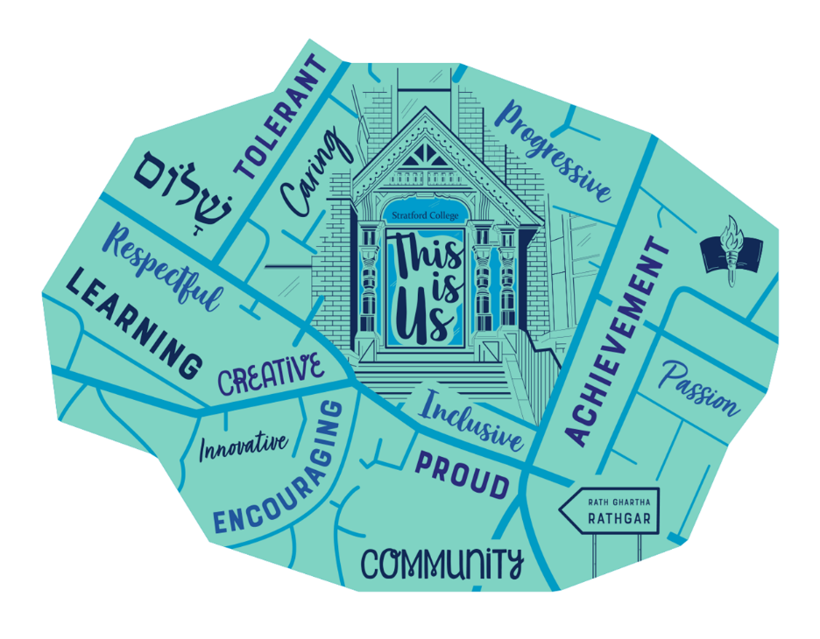

**Our Senior Cycle Guiding Principles**

***Quality****; Our Senior Cycle Programme will offer all learners a high quality education, characterised by high expectations of the learner and the pursuit of excellence. It will aim to generate engagement and enthusiasm and encourage participation.*

***Inclusive education****; the experience of Senior Cycle will be inclusive of all learners and contribute to the achievement of equality of opportunity, participation and outcome for all*

***Continuity;*** *the curriculum will build on students’ learning to date, actively support their progress in learning, and facilitate them in preparing and planning for future learning*

***Lifelong learning****; Students will develop the skills of managing and directing their own learning that will assist them in meeting the challenges of life beyond school, in further and continuing education, and in working life.*

These principles will continue to guide our thinking as new subject specifications become available and short courses are considered.

We communicate our progress and national developments on our website, in our annual School Improvement Plans, at our annual curriculum evening and information evenings and regularly at our Board meetings.

**School Self Evaluation (SSE)** and **School Improvement Planning (SIP)** will continue to prioritise areas of development in teaching and learning and by so doing improve students’ learning experiences and outcomes in this and all our programmes.

**HOW TO MAKE YOUR SUBJECT CHOICE**

1. Think about what it is you might like to do when you leave school. If this

requires further study look up www.qualifax.ie. Look and see what courses are

on offer and do a random check for subject requirements for this type of course.

Some courses require you to have studied a particular subject at leaving cert

level in order to gain entry into the course. e.g. Medicine requires two science

subjects including chemistry.

2. Now look at the list of subjects and pick out the ones you enjoy, then pick

out the ones you think you can do well in. Keep in mind that scoring points is

important if you wish to go on to third level education.

3. Some students choose to take a broad range of subjects (e.g. one from each

area, business, science, humanities and practical) as they are not sure what they

want to do. This is not always necessary as most courses do not have subject

requirements and even if you do not study the subject at leaving cert you could

go on to take it a third level. e.g. you do not need to have studied business to do

a business studies degree.

4. It is also wise to do some research as to what subjects entail at leaving cert level.

There can be a huge jump in the standards expected of you or the weighting

given to the practical side of the subject.

**Do not:**

1. Choose your subjects based on what your friends are doing.

2. Choose your subjects based on what teachers you think you might or might

not have.

3. Choose your subjects on what other people tell you about how easy or difficult

a subject is. Every person will find different areas easy or difficult according to

their ability.

4. Choose a subject without researching what it entails at leaving cert level.

**In conclusion the following considerations must be borne in mind**

**when choosing subjects for Leaving Certificate:**

• Basic Entry Requirements for the college in question

• Specific course entry requirements

• Choose subjects on the basis of interest, aptitude, possible career paths and

achievements to date in exams or tests.

**Our Senior Cycle Programme**

|  |  |  |  |  |
| --- | --- | --- | --- | --- |
|  | | **Subject** | **Year 1** | **Year 2** |
|  |  |  | **No. of Periods** | **No. of Periods** |
| Core Subjects | | Irish | 3 | 3 |
| English | 3 | 3 |
| Maths | 4 | 4 |
| Option | | French | 3 | 3 |
| Band 1 | | Biology/Accounting/Music | 3 | 3 |
| Band 2 | | Geography/Art/Chemistry | 3 | 3 |
| Band 3 | | History or Politics & Society/ Physics/Business | 3 | 3 |
| Band 4 | | Classical or Jewish Studies/LCVP/ Computer Science | 3 | 3 |
| Wellbeing | | PE | 1 | 1 |
| SPHE/Guidance | 1 | 1 |
|  | | ICT | 1 | 1 |
| **Total** | |  | 28 | 28 |

Students will study eight (8) subjects for the Leaving Certificate programme

Each of these subjects have 3 periods a week and the core subjects of Irish**\*,** English, Maths have 4 periods a week. Information on all subjects is available in the Senior Cycle Subject Choice Booklet.

Non-nationals and DES exemptions may apply.

*Please note all subjects are offered subject to demand and staff allocation.*

**OPTIONS**

*You may choose a subject from each of the blocks below. Please circle your choice down the list:*

|  |  |  |  |  |
| --- | --- | --- | --- | --- |
|  | **BAND 1** | **BAND 2** | **BAND 3** | **BAND 4** |
| **French** | **Biology** | **Chemistry** | **Physics** | **Classical Studies** |
|  | **Accounting** | **Geography** | **History**  **Or**  **Politics &**  **Society** | **\*Jewish Studies/**  **Hebrew Studies** |
|  | **Music** | **Art** | **Business** | **LCVP** |
|  |  |  |  | **Computer Science** |

Jewish Studies is compulsory & restricted to Jewish Students

LCVP Links Module can be studied if a student has at least one of the following combinations of subjectswith French or another European Language

In addition: Physical Education (PE), Guidance including Careers & Social, Personal, Health Education (SPHE).

**ACCOUNTING**

Accounting involves the recording of financial information by an individual, voluntary organisation or business, the presentation of this financial information and the interpretation and uses of this financial information.

**A STUDENT CHOSING TO STUDY ACCOUNTING CAN EXPECT TO UNDERSTAND:**

* how and why financial information is recorded
* the information contained in Bank statements, why a Bank Reconciliation Statement
* may be needed and how to do one
* how a small business records its financial information
* how to interpret and use the information in the accounts of a business from the point
* of view of shareholders, creditors, customers and employees
* how to record, present and interpret the financial information for a voluntary
* organisation e.g. Club or Association
* the importance of financial information for good decision making.
* how to correct mistakes in accounts
* how to deal with companies who have insufficient records of business transactions
* Management Accounting - break even analysis: budgeting, cash flow statements etc.

A student will **benefit** from studying Accounting by learning how to:

* collect, organise, record and present financial information
* analyse and interpret financial information
* think clearly and logically
* perform the duties of a treasurer of a voluntary organisation properly
* prepare your own accounts if you set up your own business
* understand the key concepts of accounts

**ASSESSMENT:**

Written Exam

This will be to your advantage if you continue your studies in third level. Accounting is a course taught in many third level courses.

Accounting is useful for **careers** in:

Accountancy, Auctioneering, Auditing, Advertising, Banking, Book-keeping , Building Society Clerk, Business Law, A Vast Array of Clerical Work, Company Secretary, Hospital Administration, Hotel Management, Insurance, Market Research, Purchasing

Officer, Quantity Surveyor, Receptionist, Sales Representative, Taxation Consultant, Teaching, Computers.

**ART**

Art is a subject which is useful in every walk of life. It teaches the skills and approaches of communicating visually. It has links in practically all other subjects at second level.

In every discipline or career, an Art education offers problem solving skills, design processes and heightens visual awareness. Art introduces students to the practical world, developing manual skills as well as academic skills. It also deals with problems that need a lateral approach exploring creativity and ideas.

For students preparing for Art Colleges - it is essential to study the subject for Leaving Cert. Apart from taking it with a view to a career the highly motivated student of Art could count on "A" or "B" grades. A portfolio will probably be needed for entry to Third Level Art Course. Art is acceptable in place of the language requirement for students entering NCAD. In preparation for entrance to Art Colleges, the portfolio requires a great deal of structured project work and fosters the student’s developmental approach to problem solving. In short, Art provides an all-round visual and conceptual education.

**ASSESSMENT:**

* Written examination in Art History and Appreciation
* Life drawing and sketching exam
* Choice between Art Design exam and an Art Craft Work exam
* 50% of coursework is a project completed over 10 weeks in final year

**Art is useful in careers in:**

Textile Design, Graphic Design, Computer Graphics, Advertising, Architecture, Environmental & Industrial Design, Art Teaching & Education, Printing & Publishing, Marketing and Design, Interior Design, Occupational Therapy, Painting & Decorating, Fashion, Gallery and Museum work, Craft work, Fine Art, Printing & Multi-Media.

**BIOLOGY**

More than any other science, Biology is part of everyday experience. When you visit a nature reserve, watch the behaviour of a pet animal, or collect a prescription from the chemist, there is a close encounter with Biology. Switch on the T.V. for a documentary on transplant surgery on AIDS, or open a familiar textbook, and it is clear that peeling off the surface layer of the biological onion reveals some fascinating science underneath.

At another level, open your newspaper and read about the success of a new biotechnology company, or a new campaign by Greenpeace, and the economic and political importance of the subject can be seen.

**From the employer's viewpoint there are some qualities developed during the study of biology which make it especially valuable as a preparation for other jobs.**

* Because of the complexity of living things, studying them usually involves dealing with a wide range of variables and complex sources of data. Interpretation requires judgement and, at times, the ability to compromise. As such this is a good preparation for real life problems outside science e.g. in managing people.
* Most biologists become familiar with statistics and computers used in data processing. This skill is directly transferable to many other jobs.
* Field work and some laboratory work, can be a team activity. Taking personal responsibility and learning to work together with others in a group, are qualities valued highly by employers.
* Speaking the language of science is a high valuable asset in this era of high technology.

**ASSESSMENT:**

Written exam only in 3 areas: (1) study of life; (2) the cell; (3) the organism with 22 mandatory activities.

**Biology is useful for careers in:**

Health Professionals, Nursing, Environmental Officers, Chiropodist, Dentist, Dietician, Optician, Pharmacist, Radiographer, Speech Therapist, Veterinary Surgeon, Publishing, Journalism and broadcasting; Library work and Information Science; Environmental Conservation; Marine and Freshwater Biology; Animal Nurse; Education; Horticulture; Zoologists; Food Industry; Production Management, The Brewing Industry.

**BUSINESS**

Business Organisation is a subject that touches everyone’s life, whether we know it or not. You cannot turn on a television, listen to a radio or read a newspaper without coming into contact with the subject. Every time we get a job, join a trade union, take out an insurance policy, save with a financial institution, pay tax, visit a shop, factory, co-op etc. we are living the Business Organisation course.

**What things can you expect to study in Business?**

* the different types of business units which exist and how to set one up: sole traders, partnerships, companies.
* the different types of industrial and agricultural enterprises in Ireland and the way they help the development of our country.
* understand that for a business to operate efficiently it will require many services: finance, banking, insurance, market research, advertising and sales promotion, transport.
* understand and be able to present information in a variety of forms e.g. Reports, Agendas etc.
* understand that competitiveness is the key to survival in the Single European Union.
* understand the importance of good open communication in a business with your customers, creditors and employees.
* understand the Principles of Good Management within organisations.
* understand the importance of the State in promoting enterprise within Ireland: helping to set up a business, the state agencies which are there to help business and the legislation in existence to protect all people who deal with businesses: investors, customers and employees.

**How will you benefit from studying Business?**

* you will be able to calculate your own income tax and PRSI
* you will understand your rights as a Consumer and how you are protected by the law.
* you will understand how and why you should consider various types of insurance cover.
* you will know about services available from the financial institutions: saving, borrowing etc.
* you will understand the role of trade unions in a modern society and the way they, and the state, protect workers.
* you will understand how to be enterprising as an individual, as a member of your community and as a business person, should you decide to set up your own business.
* you will understand the environment within which a business operates in Ireland, in the European Union and in a world-wide context.
* you will understand the key concepts of business. This will be to your advantage if you continue your studies in third level. Business is a course taught in many third level courses.

**ASSESSMENT:**

Written Exam

Any student with a keen interest in business may choose this subject.

**Business is useful for careers in:**

Industry, Business, Accounting, Banking, Book-keeping, Clerical work, Company Secretary, Hospital Administrator, Hotel Management, Insurance, Purchasing Officer, Typist, Sales, Marketing, Merchandising, Customs and Excise, Receptionist / Telephonist, Taxation, Teaching, Law, Store Management.

**CHEMISTRY**

Chemistry is the science of how materials interact with each other in the world around us. The whole world is made up of atoms and molecules which we cannot see, chemistry opens up this world for students to discover and understand.

**Why Study Chemistry?**

Chemistry is one of the most practical based of the laboratory sciences with a large emphasis of the course based on learning practical skills in the lab.

In the Leaving Cert Chemistry course we study the history of chemistry, the development of the periodic table and discoveries which led to us understanding the structure of the atom.

We also study Organic Chemistry which is the chemistry behind many everyday substances we use, for example, medicines, pharmaceuticals and cosmetics.

We look at environmental chemistry and study the causes of pollution in air and water, global warming and discuss how to combat these challenges.

Chemistry allows students to see the world in a totally different and unique way, which will help them in all their future studies and work.

ASSESSMENT:

Written exams only – incorporates assessment of practical work which was carried out during the course.

**Careers in Chemistry**

Pharmacy, Pharmaceuticals, Medicine, Physiotherapist, Radiographer, Nursing, Veterinary, Dentistry, Forensic Science, Materials Technology, Photographic processing, Chemical Engineering, Industrial Chemistry, Polymer Science, Geochemistry, Teaching, Biochemistry, Biotechnology, Forestry, Agriculture and Food Science etc.

**CLASSICAL STUDIES**

Also known as Greek & Roman Civilization this subject incorporates a study, through English, of Greek and Roman culture and civilization.

For Leaving Certificate purposes "Classics" includes the study of Greek Drama, Epic, History and Art. The wide variety of topic areas leaves the subject accessible to most pupils.

**Why study Classical Studies?**

1. So much of the ancient world is a foundation for the present e.g. literature, philosophy, democracy & art etc.
2. Classical Studies is a unique and varied subject. The vast majority of students taking it will retain their interest in and regard for the subject long after they have finished with it.
3. Students of Classics have highly trained minds which enable then to take up careers in many areas.

**Classical Studies is useful for careers in:**

Classics is of benefit for pupils who intend to pursue certain subjects in university i.e. ARTS including English, Drama, History, Classical Studies, Philosophy and Sociology to mention a few.

Other professional areas such as Art & Design, Architecture, Engineering, Law and Journalism also have a large classical element.

**COMPUTER SCIENCE**

Computer Science is problem solving, the study of computers and algorithmic processes. Leaving Certificate Computer Science includes how programming and computational thinking can be applied to the solution of problems, and how computing technology impacts the world around us.

The specification is constructed into 3 strands, whose learning outcomes are interwoven. The 3 strands are:

1. Practices and principles
2. Core concepts
3. Computer science in practice

Students will learn:

* + - The practices and principles of computer science, such as computational thinking, computers and society, and creative design
    - How to analyse problems in computational terms and understand concepts such as abstraction, logic, algorithms, computer systems, data representation and evaluation
    - Programming languages and how to read, write, test and modify computer programs.
    - The process of designing computational artefacts such as web pages, digital animations, simulations, games, apps and robotic systems
    - The ethical, historical, environmental and technological aspects of computer science, and how it impacts the social and economic development of society

Students learn programming by solving problems through computational thinking processes and through practical applications such as applied learning tasks. The Leaving Certificate Computer Science specification is designed for all students.

Students complete four group projects called Applied Learning Tasks:

1. Interactive Information Systems

2. Analytics

3. Modelling and simulation

4. Embedded systems

These four Applied Learning Tasks prepare the students for their individual project in mid-6th Year worth 30% of the Leaving Certificate.

The exam is worth 70% and is likely to be an online examination.

**ECONOMICS**

Economics is a subject you are already familiar with even though you are probably unaware of this fact. Everyday our newspapers, magazines, radio and television programmes keep us in touch with a wide range of economic issues - unemployment, inflation, taxation, interest-rates; privatisation, currency exchange-rates, E.U. Structural Funds; CAP reform, GATT, Third World issues.....the list is endless.

Economics is a subject which is "alive" and educates students for citizenship.

Why study Economics?

(i) When you study Economics you will gain a good understanding of current affairs both nationally and internationally, and you will be well prepared to form reasoned opinions on a wide range of matters.

(ii) Economics gives you superb training for a wide range of jobs. The subject teaches you how to collect and analyse information, to think clearly and logically. These are invaluable skills from an employers’ point of view.

(iii) Economics is a module contained in a wide range of courses at third level institutions and to have studied it at second level is of tremendous benefit. This is especially true for girls as relatively few girls nationwide take the subject.

*NOTE: It is not necessary to have studied Business Studies for Junior Cert in order to pursue Economics at Leaving Cert.*

ASSESSMENT:

Written Exam – 80%

Project (new in 2020/21) – 20% (to be completed in 6th Year)

**Economics is useful for careers in:**

Journalism, Politics; Stockbroking; Foreign Trade, Advertising; Trade Unions; Marketing and Market Research; Law; Engineering; Administration; Taxation; Banking; Research (TV and Politics); Quantity Surveying; Auctioneering; Hotel Management; Education; One may specialise in Economics and work as a full-time economist with large companies, Government departments; Stockbroking firms or organisations such as the I.F.A., E.S.R.I. or banks.

**FRENCH**

Until recently a foreign language was a requirement for entry to all colleges of the National University of Ireland i.e. UCD, UCC, University of Galway and Maynooth University, however recently these colleges have dropped that requirement for many of their engineering, science, agricultural and food science programmes. A third language is also not a requirement for nursing programmes. Art is acceptable in place of the language for students entering NCAD. You also need a foreign language to become a Cadet in the Army or Air Corps. Certain industries and employers think very highly of candidates with foreign language skills. It is important for the student to be clear if a foreign language is a requirement for their chosen course.

Learning a foreign language has the following benefits:

* enables students to communicate effectively in French by fostering the four language skills of listening, speaking, reading and writing.
* provides students with the knowledge of the grammatical workings of this language which will assist them in further study whether for academic, business or leisure purposes.
* offers insights into the culture and civilization of European Countries.
* encourages an openness of mind to the customs and culture of other peoples.

Knowledge of a continental language will always be useful and is essential for many courses at third level e.g. Applied Languages; Marketing; Clinical Speech; Primary Teaching (N.U.I.); European Studies, Computer Studies and Linguistics and Language Studies.

ASSESSMENT:

* Oral Exam – 25% in H.L., 20% in O.L.
* Aural Exam – 20% in H.L., 25% in O.L.
* Written Exam on reading comprehension and writing ability – 55%

**French is useful for careers in:**

Travel Agency and Tourism, International Marketing, transport and Communications, Export Careers, Interpreter; Translator, Journalism, Librarian, Department of Foreign Affairs, Hotel Management.

**GEOGRAPHY**

Geography is a subject which is a relevant and useful part of daily life. When you take a walk in the countryside, go to the beach, visit a heritage centre or even go shopping, you are "experiencing" Geography. Daily newspapers and magazines, radio and television programmes and the internet keep us in close contact with geographical issues - weather forecasts, earthquakes, CAP reform, industrial developments, tourism, poverty, unemployment, emigration, famine, pollution, rezoning controversies, shopping centre developments, GATT, EU enlargement, urban renewal. These are just some of the issues which are part of a subject that is "alive" and changing by the day.

**WHY STUDY GEOGRAPHY?**

* Geography keeps you up to date with current affairs in a rapidly changing world. The subject encourages in students a sensitive awareness of our environment and provides a good understanding of important issues and problems in modern society.
* When you study Geography you will acquire a wide range of skills which are extremely valuable from an employer’s point of view. Students learn how to collect, record and analyse information, draw conclusions and present sensible solutions to problems with realistic plans for action. These skills are rightly valued in the workplace.
* An individual report for writing the fieldwork is now to be submitted before the end of April and accounts for 20% of Leaving Cert result. Fieldwork is an integral part of the subject so students learn to work as members of a team, taking responsibility to complete a specific task. From an employer’s point of view this is a very important characteristic in a worker. Leaving Certificate Fieldwork is a compulsory part of the new syllabus introduced in 2004. There will also be an emphasis on Irish, European and global case studies.

ASSESSMENT:

* Both Ordinary and Higher Levels have separate written exam papers – 80%
* 20% for report on Geographical investigation

Geography is useful for careers in: Urban and Rural Planning, Tourism, Travel Agency, Archaeology, Meteorology, Pilot, Estate Agency, Environmental Protection, Surveying, Cartography, Landscape Architecture, Agriculture, Forestry, Transport and Communications, Architecture, Marketing, Leisure industry, Local Government, Education, Airline Industry.

# **HEBREW / JEWISH STUDIES**

## Hebrew

Practically, Leaving Certificate Hebrew offers the chance to build on years of Hebrew learning and earn maximum Leaving Certificate marks.

Through this course students get to grips with one of the foundations of Western Culture: to understand the roots of morality and the words of prayer, prophecy and law, and see their relevance and understand them in the context of their time and surrounding culture.

The syllabus looks closely at the structure, roles, value and purpose of the family, the social justice and political involvement of the prophets, the meaning of well-known Jewish symbols and festivals, as well as their history, observance and development; and the relationship between G-d and man.

Although the passages studied are Biblical and early post-Biblical, 80% of the vocabulary and rules of language used in modern Israel today.

The course demands a logical and intellectual approach. It forces the student to think for themselves and offers skills to enhance life.

It is a valuable springboard for further Jewish study and people who want to

go to Israel.

**Topics for Study**

Students will study two topics from the ‘Later Modern Period,

## Jewish Studies

Offered as an alternative to Classical Hebrew to Senior Cycle students the programme is designed to make the students aware of their Jewishness and to help to prepare them for leaving school, home and the Community.

**In the fifth year** the syllabus covers Prayer initially for the High Holy Days and later daily prayer.

Some isolated topics relevant to the weekly Sedra are also included. This year we looked at the Jewish attitude to justice.

A study of the Book of Esther is carried out as Purim approaches.

In tandem with these studies, **the study of Hebrew as a spoken language**, which was commenced in Transition Year, is continued.

**In the sixth year** a series of topics of general interest is covered including many topics which affect everyday life e.g. the Jewish attitude to family life and birth, the Messiah, evolution and the bible, food in Judaism, Jews in cartoons, Marc Chagall, books we have read are amongst topics discussed with Senior Cycle students in past years.

The syllabus is a flexible one to enable us to include topics of current interest, which may arise during the year e.g. in the year of Israel’s 50th Anniversary a summary of Israel’s first 50 years with key events noted was covered.

**HISTORY**

**Subject description**

History deals with the experience of human life in the past. The study of history involves an investigation of the surviving evidence relation to such experience. It brings the student of history into contact with human experiences, which are often very different from his/her own. Thus, the student gains insight into other ways of life, other ways of thinking, and other solutions to recurrent human problems. The study of human experience in the past, its particularity and its variety, is indispensable to a student’s developing understanding of the human condition and human motivation. In encountering, through the study of evidence, the past experiences of his/her own community, the student gains valuable insights into roots of his/her own identity and inherited traditions.

**Time & change – the essence of history**

Since change is an essential aspect of the human condition, it is a matter of fundamental concern to the student of history. Time & change, indeed, may be described as the essence of history. While other disciplines investigate aspects of human life, human institutions and cultural traditions, only history is primarily engaged with measuring the explaining the manner in which all of these have undergone the experience of change. Since the rates of historical change vary enormously (Slow moving for long-lasting structures and traditions, faster for wars and revolutions), it is the task of the historian to offer an explanation of the dynamic involved in each instance. The student of history will learn of the centrality of change to all human experience and of the complex manner in which different modes of change interact.

**Why study History?**

The study and writing of history is no more static than life itself. New evidence and new insights can lead to revision of the historical record and to a deepening of our historical understanding. This gives history a unique potential to develop the student’s skills of critical thinking. Living within a changing world the student of history will learn that his/her own judgements concerning the nature of historical events should be subjected to the most searching analysis and criticism.

**Knowledge & Understanding**

1. To develop knowledge & understanding of human activity in the past.
2. To promote understanding of the present through the development of historical perspective on issues of contemporary importance.
3. To develop knowledge & understanding of Irish, European & world history.
4. To develop students’ understanding of historical concepts.
5. To provide students with a perspective of change in a world of change.

**Skills of History**

1. To develop an awareness of different interpretations of particular historical issues.
2. To develop a range of research skills essential for the study of history.
3. To develop an appreciation of the nature and variety of historical evidence.

**Preparation for life & citizenship**

1. To develop the ability to think critically.
2. To develop positive values associated with the study of history.
3. To develop in students an appreciation of the society in which they live and of other societies, past and present.
4. To develop in students an informed & critical awareness of their historical inheritance.

**Objectives**

Students should acquire knowledge & develop understanding of :-

* The specific listed elements of the topics studied
* How the actions & experiences of previous generations have helped influence the world of their successors
* How elements of the Irish history topics studied fit into a broader international context. Depending on the topic in question, that context may involve consideration of such aspects as:
* The British dimension
* The European dimension
* The Irish diaspora
* Human activity in the past, from a variety of perspectives. In studying human activity in the past, attention should be given to the experiences of women. The main forms of activity to be studied may be categorised as:
* administrative
* cultural
* economic
* political
* religious
* Scientific *and* social

History is beneficial for a wide range of careers and will help prepare students for the skills and challenges of 21st century society.

ASSESSMENT:

* Project on a special topic completed prior to sitting final exam worth 20%
* Final exam – 80%

**Leaving Cert Vocational Programme (LCVP)**

The Leaving Cert. Vocational Programme (LCVP) is a Senior Cycle Programme of the Department of Education and Science and adds a strong vocational dimension to the Leaving Certificate (established). The programme combines the virtues of academic study with a new and dynamic focus on self-directed learning, enterprise, work and the community.

**Programme Requirements**

* + At least five Leaving Certificate subjects that contain Irish, a Modern European Language and two subjects selected from the Vocational Subject Groupings.
  + Two Link Modules: Preparation for the world of Work and Enterprise Education

**Link Modules**

*Link Modules I – Preparation for the World of Work*

Students will investigate local employment opportunities, develop job seeking skills and gain valuable practical experience of the world of work.

*Link Module II – Enterprise Education*

Students will be involved in organising visits to local business and community enterprises: meet and interview enterprising people on – site and in the classroom; plan and undertake interesting activities that will build self-confidence, creativity, initiative and develop teamwork, communication and computer skills.

ASSESSMENT:

* Written examination (40%)
* Portfolio of coursework (60%)

*Leaving Certificate Points*

Distinction: 66 points

Merit: 46 points

Pass: 28 points

**MUSIC**

Music is essentially an aesthetically pleasing form of expression. It is an academic art form, yet an extremely creative subject which allows the student to develop artistically, emotionally and psychologically. It requires concentration and listening skills of the highest level, skills which are essential in the workplace, and skills which are recognised by the employer. Music provides the student with a broader education, which incorporates the technique of whole-brain learning (both spatial and logical).

**The structure of the course has changed to allow students to specialise in the syllabus activity which best suits their talents. As with the Junior Certificate Music programme, the course is divided into three areas:**

**1. Performance (25%), Singing/Instrument/Improvisation: Solo, ensemble**

**2. Listening (25%)**

**3. Composition (25%)**

**Students will then choose an elective in one of the sections above, for a further 25%.**

Computer technology can be included in all parts of the course. This facility is provided at Stratford College.

Students who wish to further their musical education at third level must study music for the Leaving Certificate. In recent years, Leaving Cert Music students received the highest percentage of A grades, across the curriculum.

**Career Prospects:**

*Music Industry:*

Publisher/editor (periodicals, music books, music software)

Music software programmer

Music management and sales

Newspaper critic and reporter

Recording engineer

Concert promoter

Conductor

Performer of the Arts, Composer: Advertising, Film .

*Television/Radio Industry: Education:*

Music editor, producer, composer Primary, Secondary, Third Level

Sound mixer, engineer Librarian / Researcher

Copyright/clearance administrator Music Therapist

Disc Jockey/video jockey

Programme director

**PHYSICS**

Physics is the most exciting part of all science and technology. It explains everything from the smallest atoms to the largest galaxies in the universe; it involves living as well as non-living things. Through Physics we begin to understand why things behave as they do, and with Physics we attempt to solve stimulating and important scientific, practical and social problems.

A knowledge of physics is needed:

* to set up satellite communications.
* to investigate "black holes"
* to construct a computer
* to detect flaws in structures
* to make new materials
* to study pollution of air, land and water
* to take scans for the human body
* to reduce noise in vehicles
* to harness energy of all kinds
* to solve crimes

and to understand so many other things which affect everyone's life, every day.

Successful physicists need imagination and creativity. They also need mathematical ability. It is not enough to describe an event using words as words can sometimes be ambiguous. Therefore mathematics is used since every term has a precise meaning. Explanations and theories require to be tested so a physicist may need to be practical. He/she will often have to design and build equipment and then be able to record events objectively and accurately.

ASSESSMENT:

* Written Exam

**Which careers involve physics**

With a basic degree in physics a wide variety of careers is open up to the aspiring physicist. A physicist may opt for pure research, trying to understand how the world works for its own sake rather than for any practical application. For example, astrophysics involves the study of the nature of space and time, the beginning and the end of the universe, the evolution of the stars and so on. The study of fundamental particles seeks explanations for the structure of matter and the forces regulating the behaviour of matter and the forces regulating the behaviour of matter. On the other hand, applied research in physics is directed towards a specific end such as the development of new products.

**Careers** are available in many areas. Some examples are given below:

Industry - research and development in the metallurgical, semiconductor, food electrical and aerospace industries.

Academic - teaching and research at second and third level.

Environment physics - the monitoring of pollution, assessment of noise hazards in industry, making roads safer, looking for better living and working conditions.

Energy - developing new sources of power (e.g. wind power, fusion), improving existing sources of power, safety.

Health - physics is involved in many areas of health care such as the use of ultrasonics in determining the health of the unborn baby, radioisotopes to give information on the position and extent of a cancerous tumour, large radiation sources to kill tumours, cardiac pacemakers to give an ailing heart a helping hand.

Remote sensing this is a method of obtaining information about the earth's surface and atmosphere using data obtained by aircraft and satellites. The interpretation of images may be used to provide information on the environment, weather, oceans, etc.

Communication - telecommunication, scientific journalism, publishing, T.V.

There are many more careers available to someone with a good grounding in physics and many may be taken up at one of several levels:

Technical; Scientific Assistant, Experimental Officer, Engineering Technician (including Sound Technician for the music industry), Scientific Officer, Scientist, Engineer.

**POLITICS AND SOCIETY**

**Subject Description**

Politics and Society aims to develop the learner’s capacity to engage in reflective and active citizenship, informed by the insights and skills of social and political sciences. The changing local, national and global environment presents many challenges and opportunities for young people. It also requires of them a range of skills, knowledge, values and attitudes so that they can achieve their goals in this environment. These include: skills in critically assessing information and its sources and in gathering and processing information intercultural skills to enable them to communicate and work with people from diverse backgrounds in employment and in other settings an understanding of the processes of globalisation and individualisation and their opportunities and challenges the imagination to think creatively and to propose new and alternative futures a willingness to play an active role in their society a disposition towards taking responsibility for the outcomes of their actions.

**Why Study Politics & Society**

Drawing in particular on the skills of critical thinking and imagination and on the content knowledge of sociology, anthropology, political studies and philosophy, Politics and Society can, in collaboration with students’ learning outside school, in home and community contexts, provide an opportunity for students to develop the above skills, knowledge, values and attitudes. The distinctive analytical frame of reference of these subjects can also help to develop critical analysis skills that enable people to make an informed, considered and effective contribution to their society. The content of these subjects can support the development of an understanding of equality, inequality and diversity in a range of areas of human life, including gender, ethnicity and social class. In this way, Politics and Society can contribute to the development of active and participatory citizenship through education. It can play a key role in informing people as to how social and political institutions operate at local, national, European, and global level, and of the importance of political and social institutions in shaping our society. Through active and participatory learning and through the experience of learning in the wider community, Politics and Society can enable young people to develop the skills appropriate for active and thoughtful participation in the life of their communities.

Politics & Society is beneficial for a range of careers and will prepare students for the skills and challenges of 21st Century society.

**Our Well Being Programme**

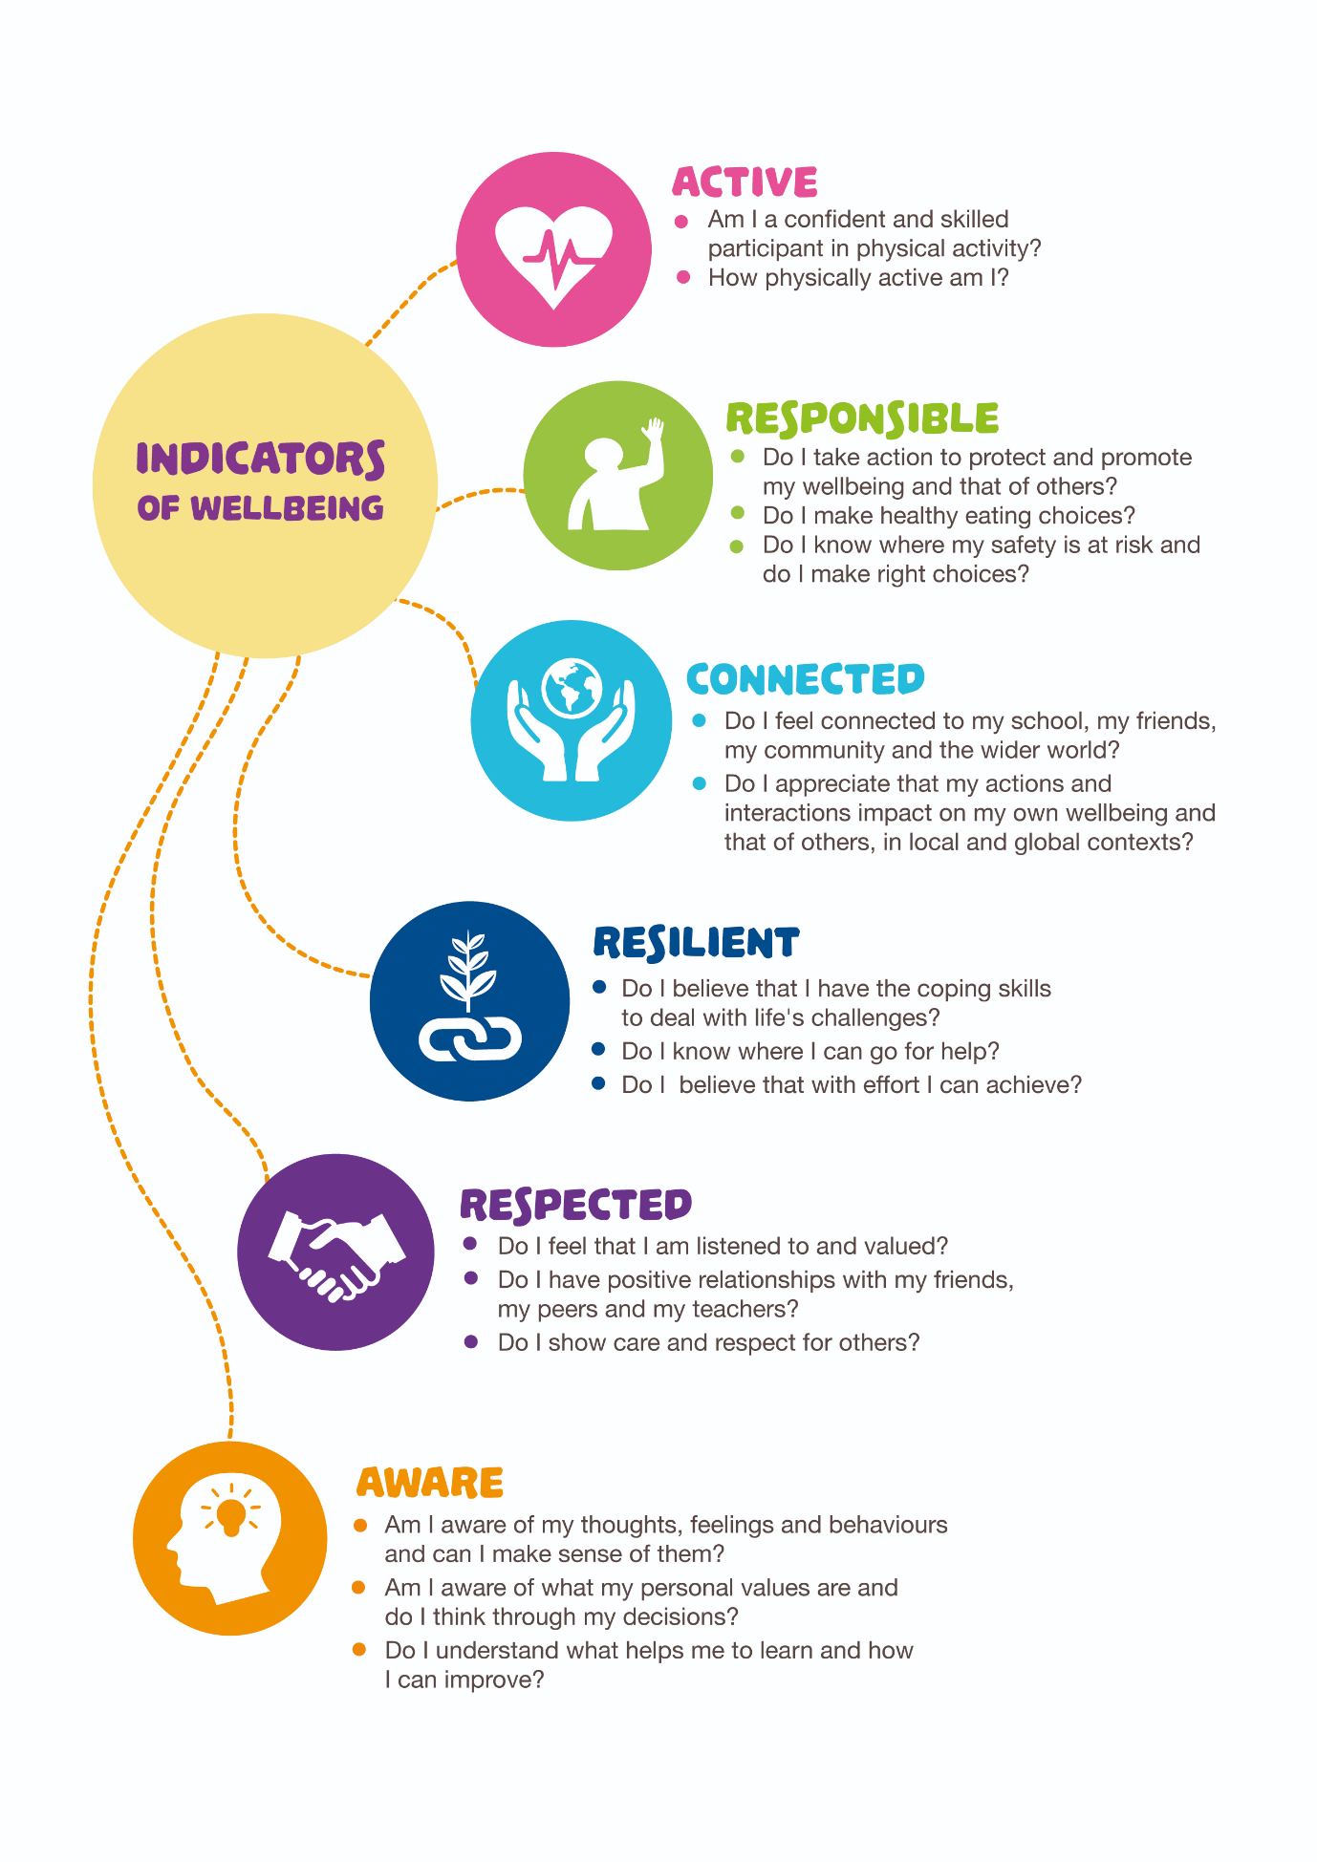[NCCA Well Being Guidelines 2017](https://www.ncca.ie/media/2487/wellbeingguidelines_forjunior_cycle.pdf)

**Introduction**

Our **Well Being Programme** is the third of a three- step process with reference to key national policy documents and school policies, listed in the Appendix.

The **first,** was the development of our **Well Being Policy.**

The **second** was the development of our **Well Being Framework** which looked at four aspects of Well Being in the life of a school: The Culture, Relationships, Policy and Planning and the Curriculum. Our framework audited the provision of Well Being throughout Stratford under these headings, consulted with parents, students and teachers on aspects of Well Being so we could identify a theme for Well Being going forward.

**Our Chosen Well Being Theme is “Healthy Body, Healthy Mind”**

Following consultation with students and parents we identified ‘Healthy Body, Healthy Mind’ as our Well Being Theme from 2019-2022 ( See Stratford College Well Being Policy and Framework).

Wellbeing weaves through life at Stratford College and students engage in various aspects of Wellbeing in all subjects and, in particular, in areas such as SPHE, Guidance, IT, Music & CSPE.

Curriculum activities encourage the development of key skills such as ‘managing myself’, ‘being active’ and ‘resilience’; physical well being through PE with emphasis on the importance of exercise and nutrition, emotional well being with the practice of feeling connected.

**Structure of SENIOR Cycle Well Being Provision *(total)***

|  |  |  |  |  |
| --- | --- | --- | --- | --- |
| Well Being | Subject Area | 5th Year | 6th Year | TY |
| PE | 1 | 2 | 2 |
| SPHE incl RSE | 1 | 1 | 1 |
| CSPE | 0 | 0 | 1 |
| ICT | 1 | 1 | 2 |
|  | Guidance | 1 | 1 | 1 |

**Whole School Activities on Our Theme of ‘Healthy Body, Healthy Mind’**

A number of school activities have promoted our Well Being Theme. The winter term focused on the whole school community feeling ‘connected’ to local and wider communities.  Student Council led initiatives such as a food collection for Focus Ireland during Mitzvah Week and a Concern Fast raised money and awareness about the work of Concern.

Transition Year SPHE & CSPE participated in the Young Social Innovators Programme (YSI) and chose the theme ‘Mental Health & Young Children’. Other popular activities such as Build a Bank, SciFest and TY Classical Mini Olympics have also promoted student wellbeing.

Co-Curricular activities such as Creative Writing Club, Drama, Music Society and Film Club facilitate wellbeing as students to feel empowered and emotionally connected through Arts and Culture.

More active pursuits such as Tennis, Basketball, as well as Coderdojo and Gaming Club offer another area where students feel connected to their school community.

*Wellbeing Week*

We know that the mental health and well-being of our children is critical to success in school and life. Education about mental health and well-being is an integral part of the school curriculum. We are taking one specific week to highlight the importance of our Mental and Physical Health.

**Evaluation**

We will evaluate our Well Being Programme, ‘Healthy Body, Healthy Mind’ in three ways.

**Firstly**,

John Murphy, a PhD student in DCU St Patrick’s campus and a PE teacher, is leading a research study into the relationship between **Physical Activity and Wellbeing.**

*“We're looking to explore the relationship between physical activity and mental wellbeing in Irish teenagers,” he said.*

*“We’re hoping that the study will show that being physically active and playing sports leads to better wellbeing and lower rates of depression and anxiety.*

*“If the study shows that, we can start doing some physical activity interventions to see how much of an impact it makes.”*

The project will focus on teenagers aged between 12 and 19 years of age.

**Secondly**

The Department of Education has asked the Educational Research Centre (ERC) to conduct an independent evaluation of implementation of the [Digital Learning Framework](https://www.education.ie/en/Schools-Colleges/Information/Information-Communications-Technology-ICT-in-Schools/digital-learning-framework-post-primary.pdf) (DLF). Stratford College has been selected to take part in this national evaluation of the Digital Learning Framework (DLF).

The DLF is a key part of the Department's [Digital Strategy for Schools](https://www.education.ie/en/Publications/Policy-Reports/Digital-Strategy-for-Schools-2015-2020.pdf). Selected schools will complete online surveys: one for the Principals or digital learning team leaders, and one for all teaching staff.

Stratford College has just completed a [major upgrade](https://www.stratfordcollege.ie/news/post/implementing-stratfords-digital-learning-framework-plan-windows-10-upgrade) of its ICT infrastructure including a Windows 10 upgrade, a server upgrade and the implementation of its BYOD policy for Junior Cycle students to support dynamic learning in the classroom.

Our Digital Learning Framework plan is based on [dlplanning.ie](https://www.dlplanning.ie/) guidelines.

**Finally,**

we will be administering the same questionnaires to students and parents to see if participation has increased and stress has been reduced.



**Guidance in Our SENIOR CYCLE Well Being Programme** **‘Healthy Body, Healthy** **Mind’**



**Guidance Programme for SENIOR Cycle**

Guidance across second level focusses on three distinct areas in the development of the individual. These are: Personal and Social Development, Educational Development, Career Development.

The planning for Guidance at Junior Cycle takes three areas into consideration and links them directly to the eight core competences within the National Centre for Guidance in Education (NCGE) [Whole School Guidance Framework.](https://www.ncge.ie/school-guidance-handbook/ncge-whole-school-guidance-framework)

**Personal and Social Development** Developing Myself

* Developing & maintaining self-esteem & a positive self-concept
* Interacting effectively with others (face-to-face & online)
* Developing & growing throughout life.

**Educational Development** Developing My Learning

* Employing effective personal learning/exam strategies
* Making educational choices in line with career aspirations

**Career Development** Developing My Career Path

* Using career related information & sources appropriately
* Understanding the world of work & life roles
* Managing career development & decision making

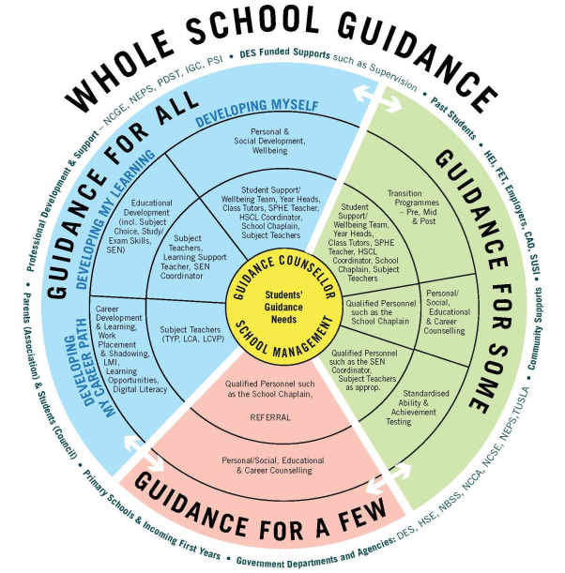

A Whole School Guidance Framework

In line with best practice nationally and internationally, Stratford College is committed to also developing and integrating a whole school approach to Guidance.  This final section of Stratford College’s School Guidance Plan focusses and outlines this whole school dimension.  This final section, also makes explicit in general terms the school’s focus on developing key areas of Learning and Competences as recommended in: “A Whole School Guidance Framework”: NCGE, June 2017.

A continuum of support model, already being employed in schools to support students’ learning and development (NEPS, 2010) and mental health promotion (NEPS, 2013), can also be applied to the school guidance programme. In applying the continuum, the whole school guidance programme aims to meet the needs of students along a continuum, from a whole school approach to group and individualised approaches. The continuum model can be applied to guidance as follows:

**Guidance For All**– provided to all students to support personal & social, educational, and career development, and students making transitions (incoming first years, junior cycle to senior cycle and from senior cycle into apprenticeships, FET, HE and employment). The guidance counsellor as the specialist has a key role to play in coordinating the planning and delivery of the whole school guidance programme and in the provision of guidance to students. A whole school approach is employed in delivering the learning and teaching activities of the school guidance programme which include, career education programmes, SPHE and Wellbeing in Junior Cycle, guidance modules and work experience/placement provided as part of senior cycle programmes (TYP, LCA and LCVP). The NEPS publication ‘*A Continuum of Support for Post-Primary Schools: Guidelines for Teachers*’ (2010) outlines whole school approaches that can be employed in relation to ‘*Support for All”*

**Guidance For Some**– provided to specific groups of students to support personal & social, educational and career development and transition making. Such groups of students will typically include, for example, students in senior cycle, especially 6th year, who will benefit from group and one-to-one guidance counselling to support educational and career decision making, and students who are making transitions. Transition points include, primary school into first year of post-primary education, junior cycle to senior cycle, and school to higher/further education and training, apprenticeships and employment. Some students may require additional and more intensive support in making transitions. Group/one-to-one guidance counselling will require the expertise of specialist school staff, such as the guidance counsellor working in collaboration with the student support team, SPHE teacher, and class tutors. The NEPS publication ‘*A Continuum of Support for Post-Primary Schools: Guidelines for Teachers*’ (2010) outlines a *Solution Oriented Framework*that can be employed in relation to ‘*School Support*(for some)’.

**Guidance For A Few**– Students may require support in meeting their developmental needs and when they experience personal crises. Some students may also require more intensive support as they make transitions and important decisions during their time in post-primary schools. This support will require the expertise of specialised school staff with the necessary knowledge, skills and competences to respond to the needs of these students and will involve the guidance counsellor, and other school staff who have been trained in meeting the needs of vulnerable students and those who may have additional needs. In the event that the student requires more intensive support, referral to external agencies and supports should be employed. In the event of a protracted referral the guidance counsellor/staff member may need to provide continued support to the student. The NEPS publication ‘*A Continuum of Support for Post-Primary Schools: Guidelines for Teachers*’ (2010) outlines supports which can be provided to students with more complex or enduring needs under ‘*School Support Plus*(for a Few)’.



**Relationships and Sexuality Education (RSE) SENIOR CYCLE Well Being Programme ‘Healthy Body, Healthy** **Mind’**



|  |  |
| --- | --- |
| Curriculum | Senior cycle RSE |
| Course requirements | 1 lesson per week TY/5th/6th |
| Assessment | Quiz’s, discussions, debates, worksheets |
| Reporting | Parent teacher meetings, reports |
| Rationale | RSE  To help young people understand and develop friendships and relationships.  To promote an understanding of sexuality.  To promote a positive attitude towards one’s own sexuality and in one’s relationships with others.  To promote knowledge of and respect for reproduction.  To enable young people to develop attitudes and values towards their sexuality in a moral, spiritual and social framework |



|  |  |
| --- | --- |
| **Supporting Programmes** | Healthfest  Aware  Trust    [An Gaisce (TY)](https://www.gaisce.ie/)  [Young Social Innovator (YSI)](https://www.youngsocialinnovators.ie/)  [Volunteering](http://localise.ie/)    [Know the Score (Substance Abuse Programme for Senior Cycle)](https://www.hse.ie/eng/about/who/healthwellbeing/hse-education-programme/training-and-resources-for-post-primary-school-teachers/know-the-score.html) |
| **External Agencies** | Talks on internet safety; Garda Siochana; Aware etc.  BrainBox |
| **Awareness Raising** | * Wellbeing Week * Stand Up Week LGBT * Friendship Week |

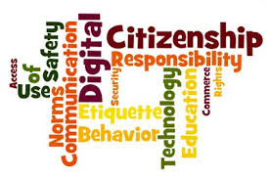

**Digital Literacy in Our Well Being Programme ‘Healthy Body, Healthy** **Mind’**



|  |  |
| --- | --- |
| Curriculum | [The Irish Computer Skills (ICS) Computing Curriculum](http://www.ics-skills.ie/education/curriculum-computing.php) & ICT Curriculum |
| Short course requirements | 100 hours. |
| Assessment | ICDL Online Modules,  Teacher/peer assessment of group project work |
| Reporting | Well Being will be included at Senior Cycle |
| Rationale | *The vision articulated in the****Digital Strategy for Schools (2015-20) DES,****published to support the National Digital Strategy is to “realise the potential of digital technologies to enhance teaching, learning and assessment so that Ireland’s young people become engaged  thinkers, active learners, knowledge constructors and global citizens to participate fully in society and the economy” (p. 5).* |



|  |  |
| --- | --- |
| **Wellbeing Indicators** | **Student Activities/ Opportunities** |
| ***Active*** | * **TY**: Introduction to foundation level Leaving Certificate Computer Science through ICDL coding and computational thinking modules * **TY & 5th Year**: ICDL Computing Curriculum modules: Computational Thinking, Microcontrollers, Multimedia Storytelling, Digital Media * **5th Year & 6th Year**: ICDL online modules * **6th Year**: ICDL Insights: Artificial Intelligence; Internet of Things, Clouding Computing, Big Data |
| **Responsible** | * **Audio/Visual technical support** for school assemblies, school-wide quizzes, school shows, Open Day * **School website**: creating digital content such as blogs, videos, audio recordings. |
| **Connected** | * Office 365 applications, including emails, Teams & OneNote collaboration spaces, Schoolwise, VSware * TY SciFest@Schools competition * TY Bebras Challenge * BT Young Scientist & Technology Exhibition * AIPO – All-Ireland Programming Olympiad * EU Code Week * Tech Week * Safer Internet Day |
| **Resilient** | * Group project work, working collaboratively online using Teams & OneNote, as well as face-to-face * Coding, debugging, error messages * Fixing technical issues: hardware and software |
| **Respected;**  **Aware** | * Rationale for all computing projects: student groups plan, design and develop computational artefacts that are personally relevant or beneficial to their community or society in general. * All computing projects should be cognisant of the role that adaptive technologies can play in the lives of people with special needs |

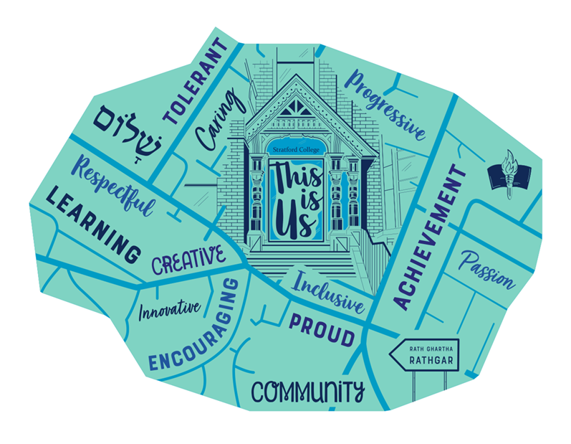

This document is offered as a guide only.

**The information contained within is not definitive nor meant to be. Furthermore it is subject to change on a yearly basis.**

**LEAVING CERTIFICATE POINTS SCORING SYSTEM:**

Grades and points introduced in 2017:

|  |  |  |  |
| --- | --- | --- | --- |
| New Leaving Certificate  Grading Scale | | New Points at  HIGHER LEVEL | New Points at  ORDINARY LEVEL |
| 90 – 100 | H1/01 | 100 | 56 |
| 80 – 89 | H2/02 | 88 | 46 |
| 70 - 79 | H3/03 | 77 | 37 |
| 60 – 69 | H4/04 | 66 | 28 |
| 50 – 59 | H5/05 | 56 | 20 |
| 40 – 49 | H6/06 | 46 | 12 |
| 30 – 39 | H7/07 | 37 | 0 |
| 0 - 29 | H8/08 |  |  |

(Additional information from Irish Universities Association: www/iua.ie)

Higher Maths grade H1 – H6 will gain an additional 25 points.

**ADVICE**

**Maths:** A pass in Ordinary Level Maths is essential for entry to the majority of courses.

The 5,000 students who fail to secure a grade 6 in Ordinary Level are in a difficult situation. Do not neglect study in this subject.

**3rd Language & Science Subjects:** A decision to drop all Science subjects or continental languages will have major implications on the range of careers open to you later on.